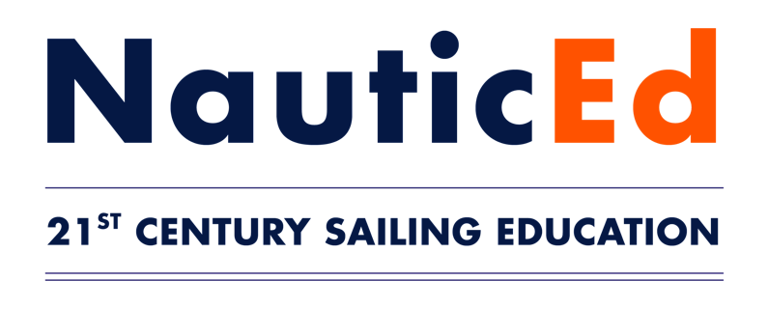
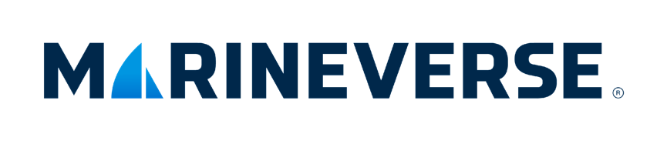

NauticEd and MarineVerse Launch
World’s First Virtual Reality Navigation Rules Course

Virtual reality is revolutionizing boating safety education
with more effective and entertaining training

AUSTIN, Texas – March 2, 2023 – NauticEd, the world leader in online and on-water sailing training, and MarineVerse, an Australian-based pioneer of virtual reality (VR) sailing simulation, today jointly announced the launch of the world's first-ever Virtual Reality Navigation Rules Training Course. This fully immersive VR course is designed to make learning navigation rules both enjoyable for users and effective for educators, using gamification techniques to entertain and increase knowledge retention.

The VR training puts players at the helm of a power boat to navigate through a challenging on-water obstacle course filled with various vessels and navigation marks – such as lateral, cardinal, and danger marks – amidst foggy conditions. Quick decision-making is crucial as it determines whether the boaters avoid obstacles or run aground. The course is designed to improve players’ reactive knowledge, enabling them to better identify and navigate around navigation marks within a timed environment.

“Virtual Reality lets us take complex and in-depth topics and make them interactive, fun, and easier to learn,” said Grant Headifen, Global Director of Education for NauticEd. “VR is particularly useful for boating education because it provides a safe environment for students to apply knowledge and practice skills without the high cost and risk of making mistakes.”

The VR program has already received praise from the Boater Education division of the Texas State Parks and Wildlife, and the Texas Parks and Wildlife website will feature the program under its Boater Education pages.

Greg Dziemidowicz, Director & Lead Developer for MarineVerse, is equally excited about expanding boating safety education through virtual reality gaming platforms. “By bringing Navigation Rules and other real, practical applications into the mix of VR sailing games, more sailors will be able to enhance their skills with Virtual Reality,” said Dziemidowicz.

NauticEd and MarineVerse previously launched the first-ever “Self Mastery” Sailing Course. Further NauticEd and MarineVerse co-developed VR training programs are set for release in Q2 2023.

Benefits to VR Learning:

- Immersive Experience: Virtual Reality allows for a fully immersive learning environment, which can greatly enhance the overall experience, reactive knowledge, and engagement of the students.

- Gamification: By making the learning process a game, students are more likely to be engaged and have fun while they learn. This helps increase their motivation and understanding of the material.

- Zero Fear Environment: The simulated VR environment removes the risk of costly mistakes, leading to faster absorption of information and improved retention.

- Hands-On Practice: The VR approach provides hands-on experience in navigating real-life scenarios, allowing students to develop their skills and knowledge in a safe and controlled setting.

- Accessibility: VR technology makes education more accessible, cost effective, and more convenient for students, as they can learn at their own pace and from the comfort of their own home.

- Repetition is key to mastery: With VR, students can repeat tasks as many times as needed, allowing for the transfer of skills and reactive knowledge from conscious to subconscious. Students can return to tasks months later to re-master the skills at any time.

The VR Navigation Rules program is available for Meta Quest 2 owners by signing up for the Virtual Reality Course on NauticEd and following the embedded instructions.

About NauticEd
NauticEd is a fully recognized education and certification platform for sailing students combining online and on-the-water real instruction (and now VR). Since Grant Headifen founded NauticEd in 2008, students have taken over a quarter million sailing courses from its e-learning platform combined with on-the-water experience via sailing partners and schools in 23 countries. NauticEd offers 24 online courses, an electronic logbook, a sailing resume tool, and six ranks of certification – all integrated into NauticEd’s proprietary platform. The U.S. Coast Guard and the National Association of State Boating Law Administrators (NASBLA) recognize NauticEd as having met the established American National Standards. For more information, please visit www.nauticed.org.

About MarineVerse
Started in Melbourne, Australia in January 2016 MarineVerse is an international team of creatives and advocates for sailing and emergent technology. With a mission to inspire, train and connect sailors around the world as well as share the unique feeling of sailing with a global audience, MarineVerse launched MarineVerse Cup in 2022 to bring virtual reality sailing to standalone headsets. For more information, please visit www.marineverse.com.

# # #

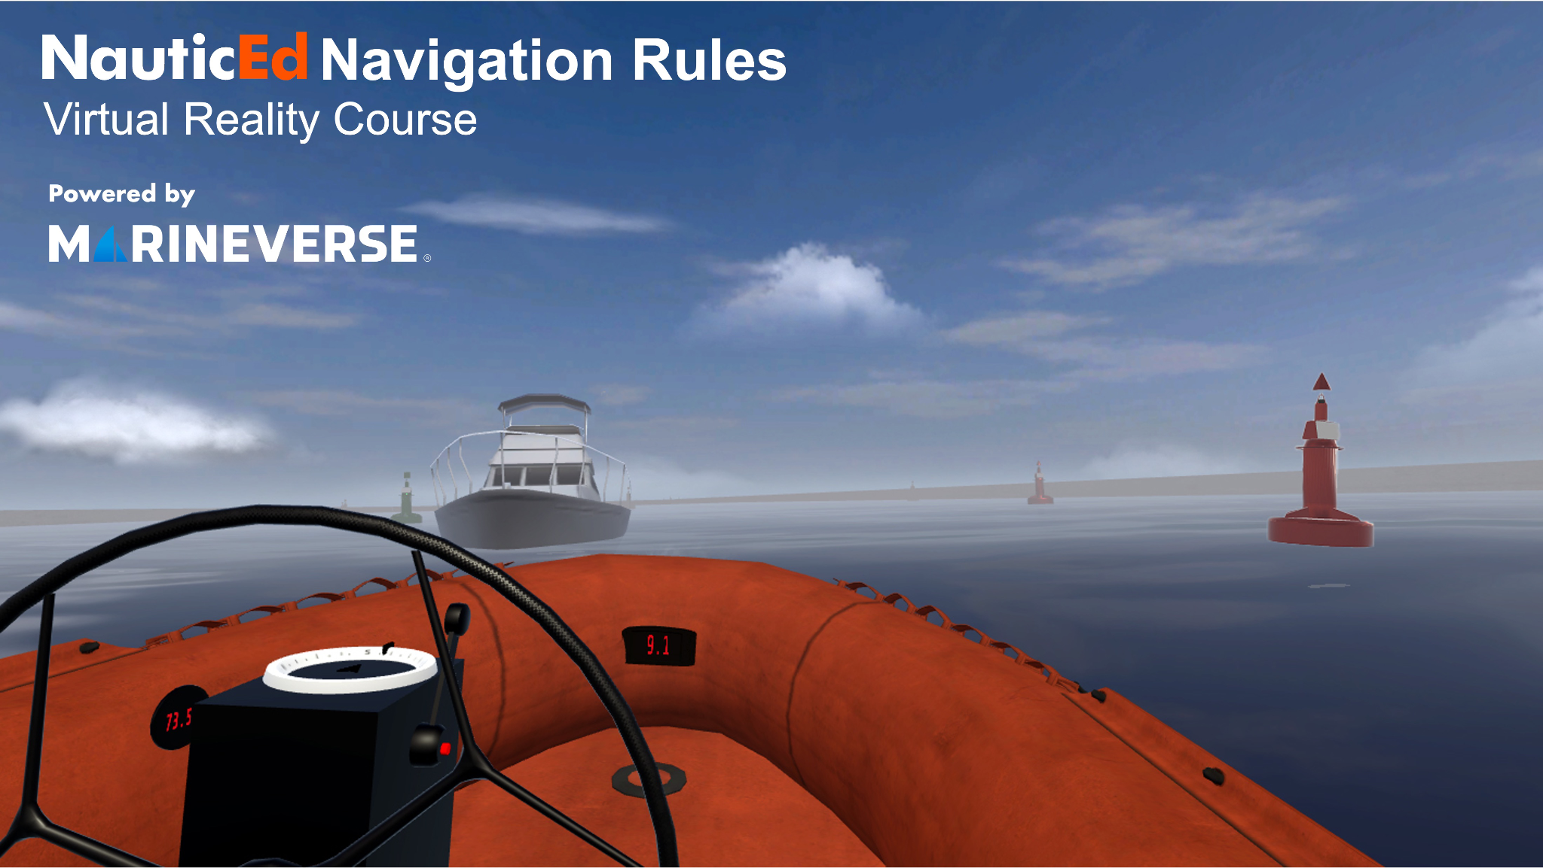
Photo Caption: NauticEd and MarineVerse launched the first-ever virtual reality navigation rules course incorporating VR gaming with sailing training techniques and programs. Participants are transported onto a virtual but highly realistic boat where they steer through a navigation obstacle course. The VR experience immediately enables them to learn the impact of their decisions in a safe learning environment.

Social Media Post: @NauticEd and @MarineVerseVR create first-ever VR Navigation Rules Course. Learn navigation rules in virtual reality! Learn, race, and explore the sailing MarineVerse.
#sailing #sailinglife #sail #sailboat #yacht #yachting #yachtlife #boat #boatlife #boating #sea #ocean #navigation #atons #navrules #vr #gaming #VirtualReality #metaquest2 #marineverse #nauticed

Media Contacts:
Grant Headifen (NauticEd) Veronique Lafargue (MarineVerse)
grant@nauticed.org vero@marineverse.com

